General Session Information
PASS is currently led by Ben Steffes (573-579-8630) and Hailey Bantle (573-517-9229)
- We will continue to meet from 3-5pm.
- We will continue to do a variety of activities, sometimes with other groups and sometimes solo!
- We will discuss the unit, “R-E-S-P-E-C-T” We will have group discussions and activities, designed to help our consumers to learn about respect and to expand on teamwork skills.
- We will have 2 outings this month, Summer is around the corner!

Outings & Other Fun Stuff
Monday May 13th: Movie Day! The group will enjoy Pizza and a movie of their voting!
Wednesday May. 22nd – The group will be visiting and spend time at Villainous Grounds and will visit Aldi’s afterwards! Please provide money for a beverage and spending money!
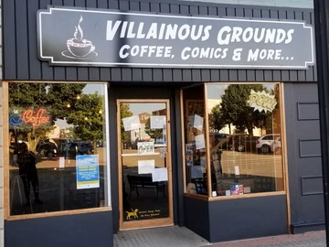
Wednesday May 29th – The group will have a picnic at Lucas and friends, Splash pad fun! This food and fun event is Free!
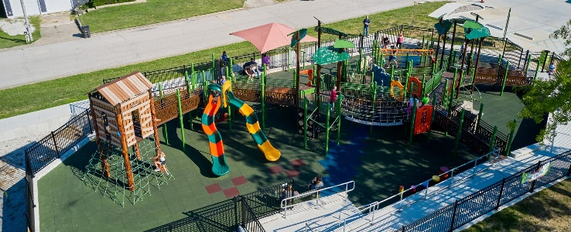

PASS May CALENDAR
*Parents – Keep this page
Mondays | Wednesdays
ssssssssssssssssssssssssssssssssssss | May 1st – Regular Session 3-5pm.
May 6th – Regular Session 3-5pm | May 8th – Regular Session 3-5pm
May 13th – Movie Day! 3-5pm | May 15th – Regular session 3-5pm
May 20th – Regular Session 3-5pm | May 22nd – Villainous Grounds and Aldi’s shopping.
May 27th – No Pass -Memorial Day! | May 29th – Lucas and Friends Park and Splash Pad! 3-5pm  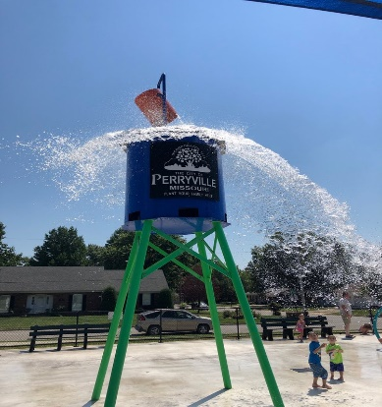

PASS (Positively Awesome Social Skills) May 2024 Permission Slip
Please sign and return it on May 20th. May outings were brainstormed and voted on solely by PASS members. This is a consent form that outlines the outings planned for March.
I consent to ____________ attending these activities as signed below.
I understand that Trendline Consulting will provide transportation to and from the outings and will provide supervision at each event. I understand that outings will expose PASS members to new environments, people, experiences, and activities. While Trendline staff will supervise participants, it is ultimately each consumer’s responsibility to make his/her own choices. I will not hold Trendline Consulting or its employees liable for injury or loss caused by ____________’s actions or decisions, except for when they are caused by gross negligence on the part of staff.
Guardian Signature | Outing Name | Date & Time | Outing Details
 | Movie Day! | May 13th 3-5Pm | Movie and Pizza- pick up at the office at 5pm.
 | Villainous grounds and shopping at Aldis | May 22nd 3-5pm | We will begin at the office & then head to villainous Grounds, followed by Aldis  . Pick up at the office at 5pm.
 | Lucas and friends park/ Splash pad and outdoor picnic | May 29th 3-5pm | We will begin at the office & then head to the park!  . Pick up at the office at 5pm.

