YASS APRIL 2024
Special Notes for March 2024:
- YASS is led by Angela Francis, Alexis Turner, and Melanie Ruark
- We have a Birthday this month with one of our members.
- On Monday, April 1, 2024, we will travel to Speck Italian in Cape Girardeau for a dining experience.
- On Monday, April 22, 2024, we will travel to Creative Ewe in Cape Girardeau for pottery making.
- We are excited to have an awesome April full of positive energy and good times!

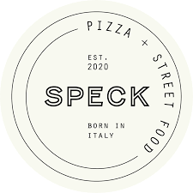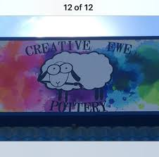

April 2024

Mondays | Wednesdays
1 YASS Spring Break/No Class | 3 Regular Class: Conflict Resolution
10 Spring Decision Day: Voting | 12 Tally Ballots & Conflict Resolution #2
15 Game Day | 17 Birthday Celebration & Conflict Resolution #3  This Photo by Unknown Author is licensed under CC BY-NC
22 Creative Ewe, FREE!  29 Regular Class: Recycle Art | 24 Baking Brownies

April 2024
(Parents send this back in)
Young Adult Social Skills Group Outing Form & Permission
Please return on or before: 04/17/2024

Outings were brainstormed, voted on, and selected by YASS group members.

I consent to _________________________________ attending as signed below. (Name of a group member)

I understand that Trendline Consulting staff will transport my child to and from the outings and will provide supervision during each event. I understand that outings will expose YASS members to new environments, experiences, and activities. While Trendline Consulting staff will supervise participants, it is each consumer’s responsibility to make his/her own choices. I will not hold Trendline Consulting or its employees liable for injury or loss that results from _______________________________’s actions or decisions except when they are caused by negligence on the part of staff. (Name of a group member)

Guardian Signature | Outing Name | Date and Time | Locations and Details
 | Speck Pizza  Cape Girardeau, MO | Wednesday  4/1/2024  3 to 6:30 pm  Cost: $20 | - Most members will meet at the office and head down to Cape.  - The cost is $20 a per person for a snack, or bring more money if you want a meal.  - Parent Pick up will be @ the Office at 6:30 pm
 | Creative Ewe Pottery  Cape Girardeau | Monday  4/22/2023  Movie Time: 4pm  Ticket Cost: FREE! | - Cost is free! It includes one item to paint, a can of soda, and a bag of chips.  - Parent Pick up at the office at 5:30 pm

